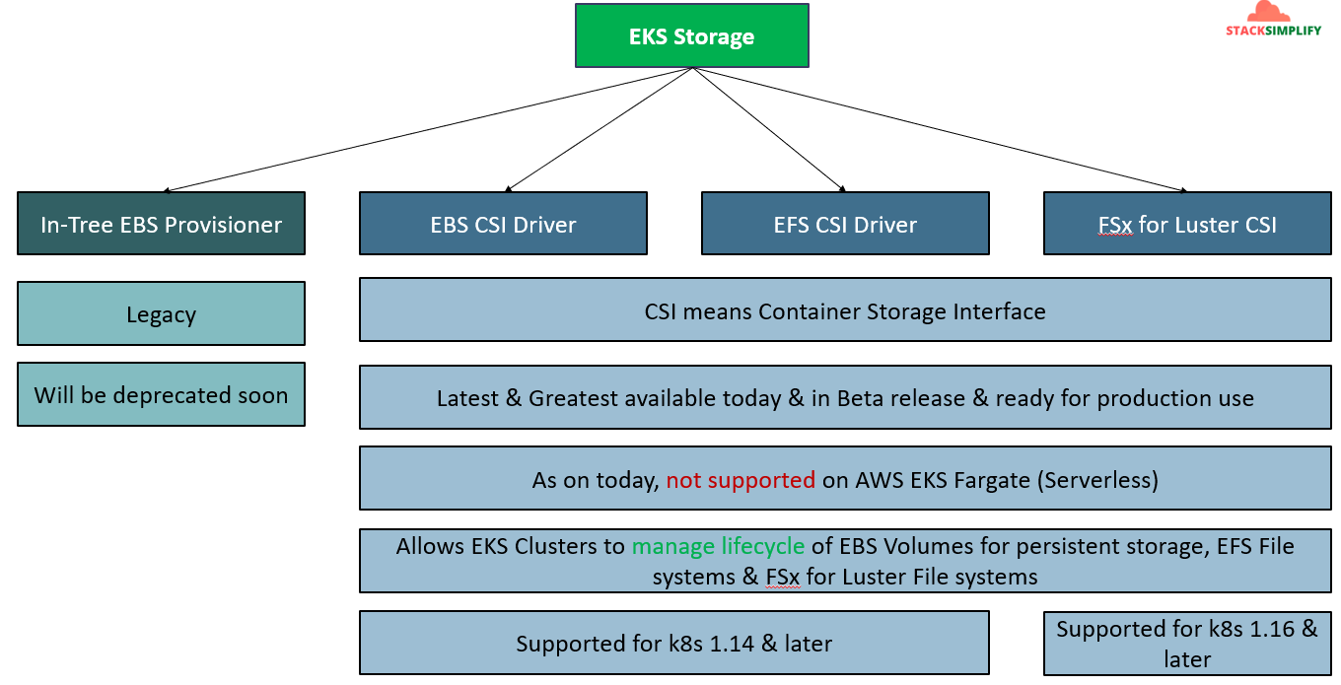
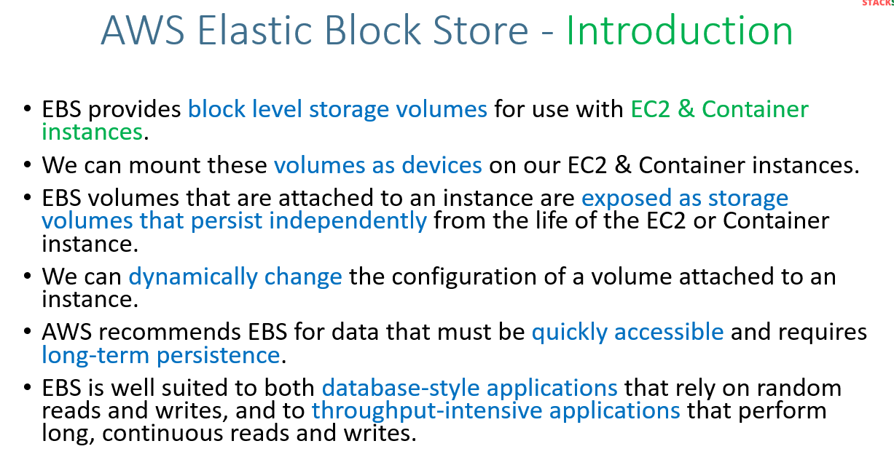
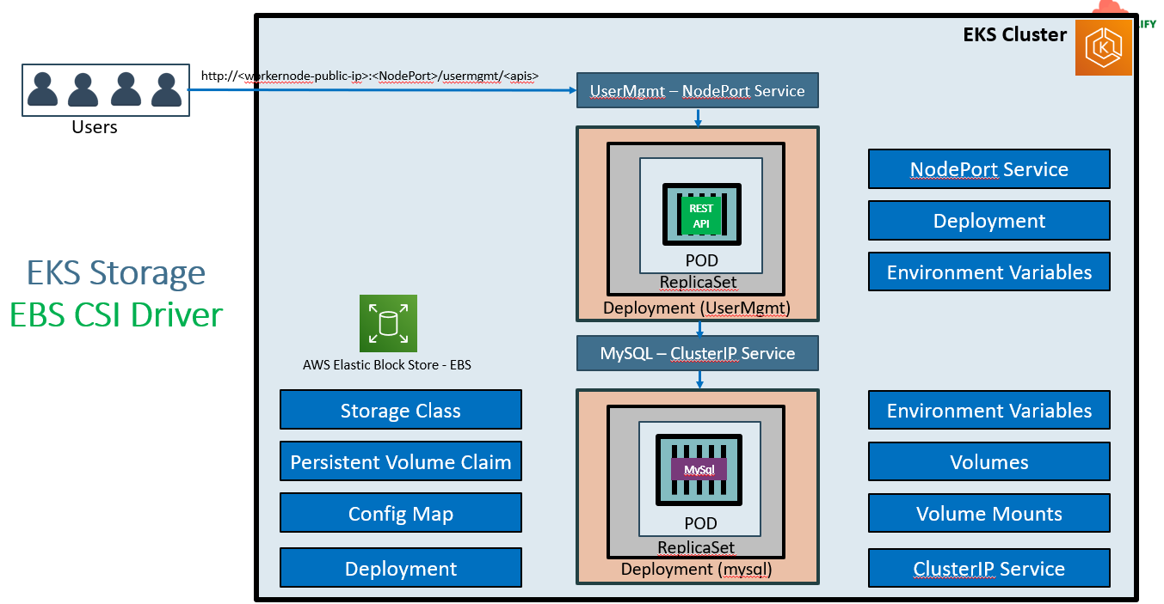
Install CSI Driver:-
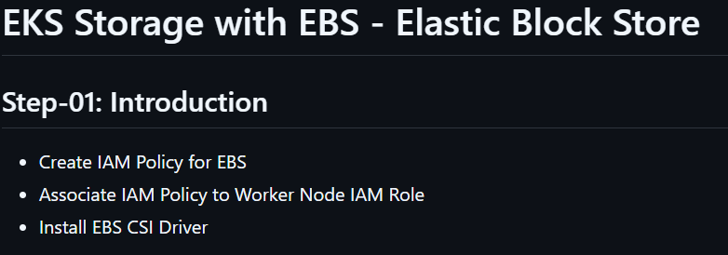
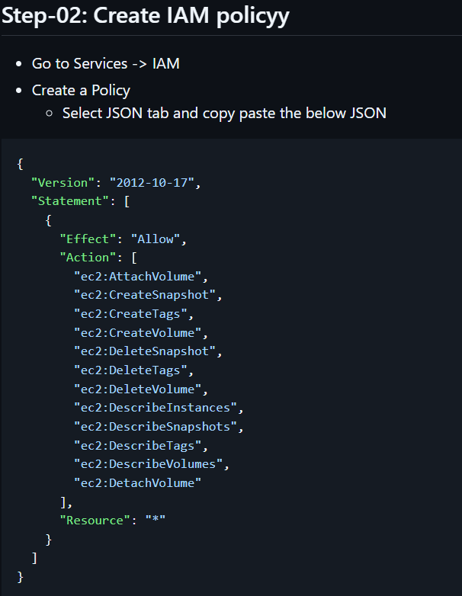
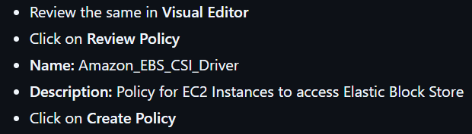
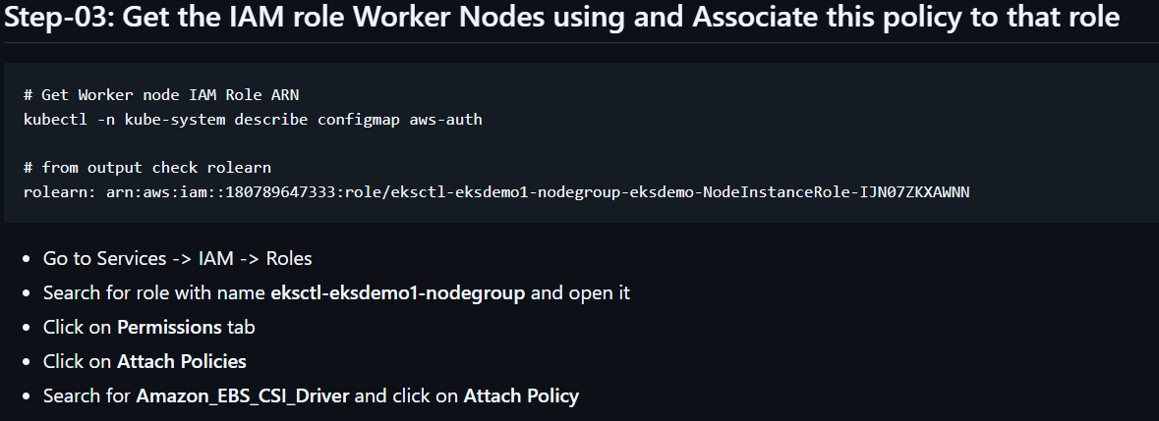
Note: you can get the node IAM role ARN directly from ec2instance.
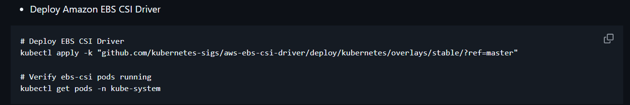
You can get the above steps from aws-eks-kubernetes-masterclass/04-EKS-Storage-with-EBS-ElasticBlockStore/04-01-Install-EBS-CSI-Driver at master · stacksimplify/aws-eks-kubernetes-masterclass .
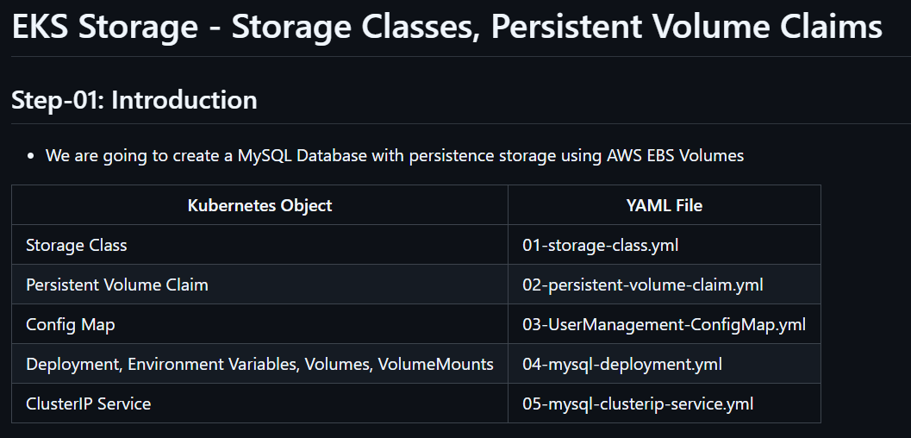
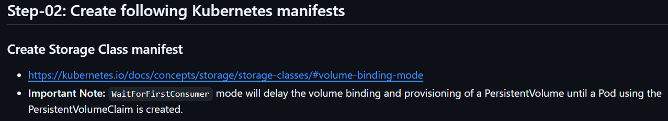
Note: If we don’t mention WaitForFirstConsumer, Suppose if your Volume got created one AZ and pod got created another AZ. We will face the issue. So to avoid that we will use WaitForFirstConsumer it will provide the volume dynamically in the same AZ.
Storage Class:
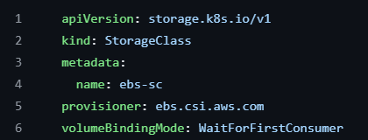
Persistent Volume Claim:
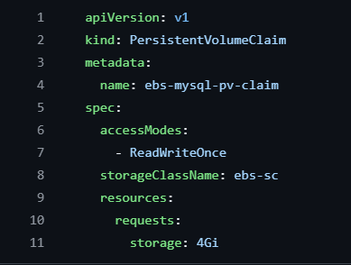
ConfigMap manifest:- Main purpose of configMap is whatever configurations you want to config to your POD you can do it by using configMap.
Eg:
We are going to create ConfiMap manifest which will be mounted in the mysql deployment. So that whenever the mysql POD got created automatically it also need to create a small schema named ‘usermgmt’.
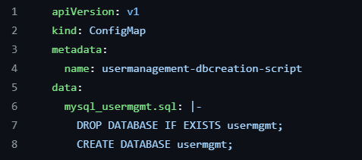
Now, run below commands and verify.
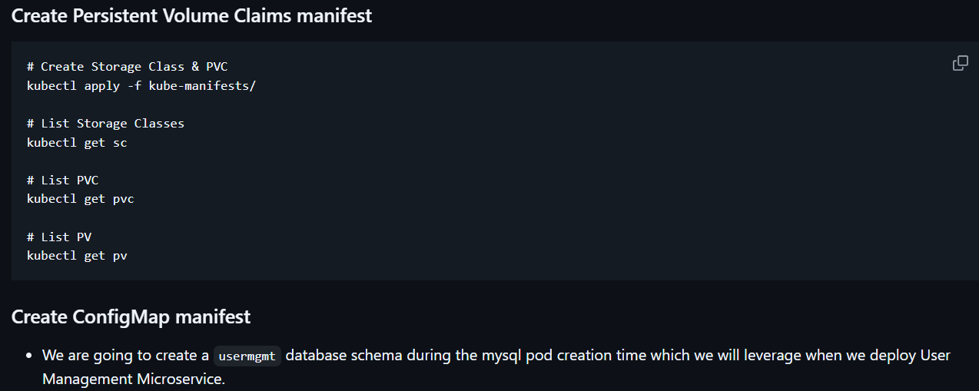
Next steps are
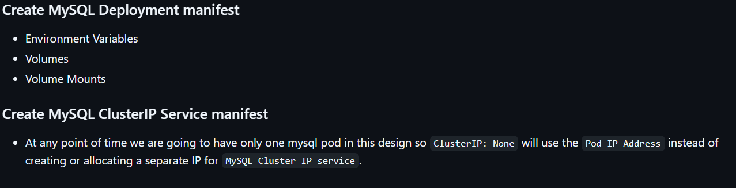
Mysql Deployment script:
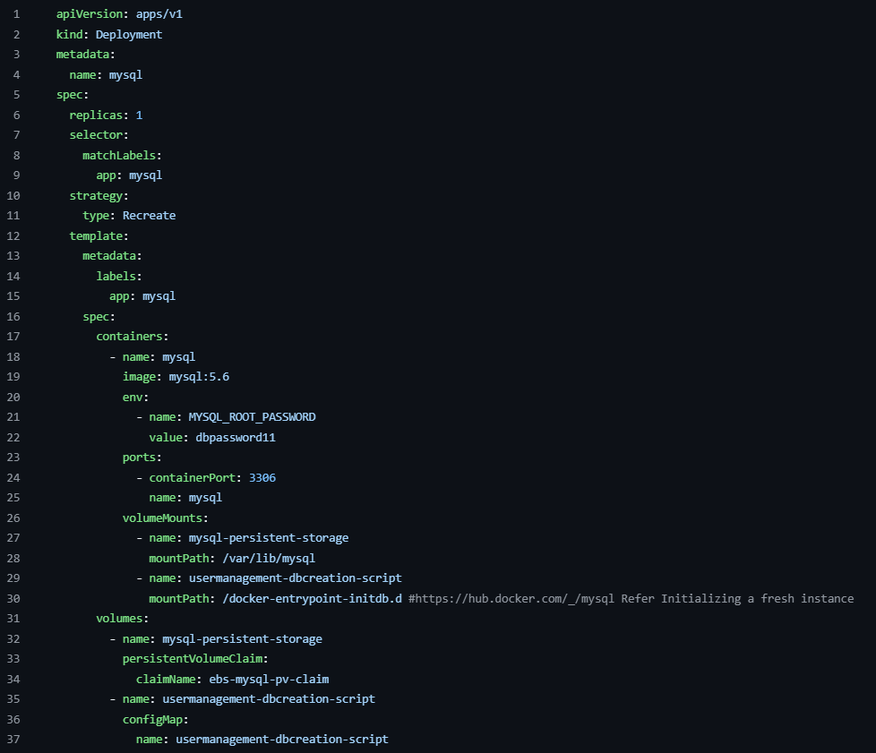
If you see strategy type: Recreate. There are 2 types 1. Rolling updates 2. Recreate.
Since we are creating DB we need to mention type as Recreate for Rolling updates it’s not required to define by default it will be Rolling updates.
If you observe voluMounts for mountPath: /docker-entrypoint-initdb.d . When a container is started for the first time a new database with specified name will be created and initialized with provided configuration variables. Furthermore, it will execute files with extension .sh, .sql and .sql.gz that are found in /docker-entrypoint-initdb.d . The files will executed in alphabetic order.
clusterIp:-
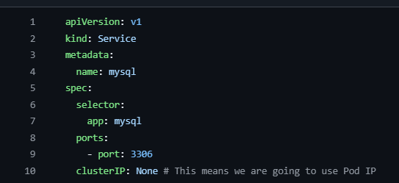
Step-05: References
- We need to discuss references exclusively here.
- These will help you in writing effective templates based on need in your environments.
- Few features are still in alpha stage as on today (Example:Resizing), but once they reach beta you can start leveraging those templates and make your trials.
- EBS CSI Driver: https://github.com/kubernetes-sigs/aws-ebs-csi-driver
- EBS CSI Driver Dynamic Provisioning: https://github.com/kubernetes-sigs/aws-ebs-csi-driver/tree/master/examples/kubernetes/dynamic-provisioning
- EBS CSI Driver - Other Examples like Resizing, Snapshot etc: https://github.com/kubernetes-sigs/aws-ebs-csi-driver/tree/master/examples/kubernetes
- k8s API Reference Doc: https://kubernetes.io/docs/reference/generated/kubernetes-api/v1.18/#storageclass-v1-storage-k8s-io
Go through official github account repos in K8s. You can explore more examples.
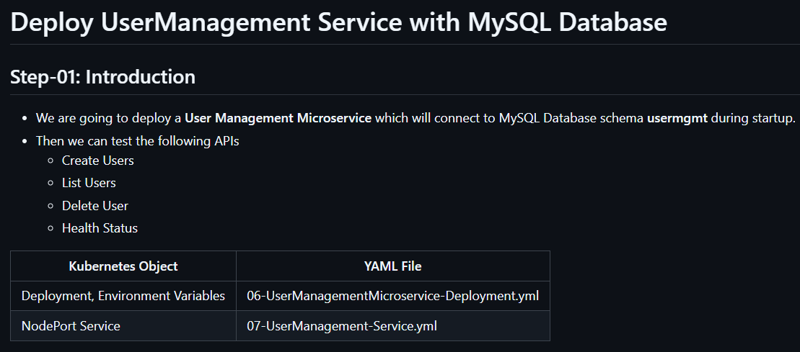
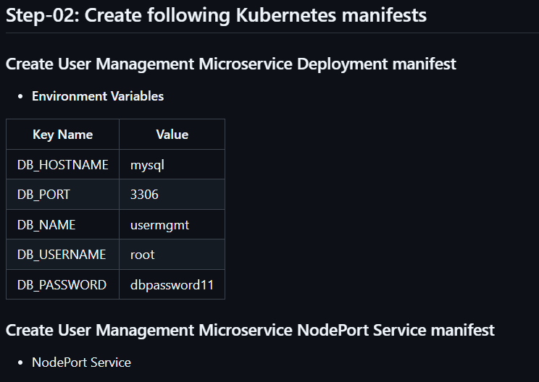
Deployment, Environment variables:
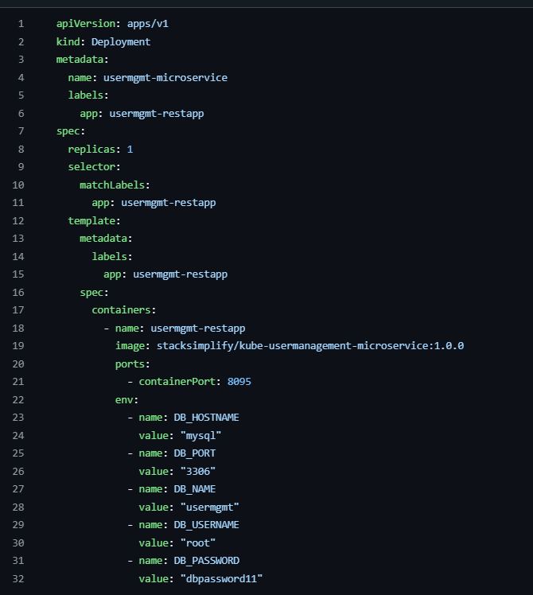
NodePort Service:
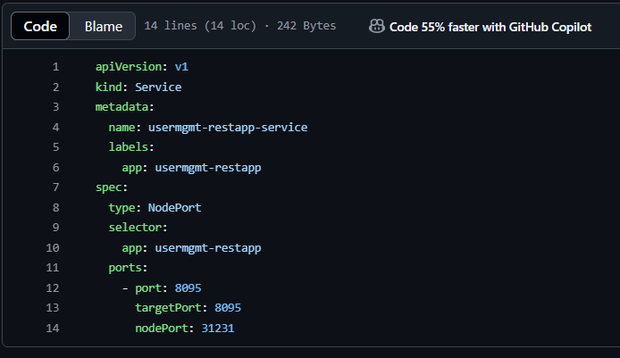

- Problem Observation:
  - If we deploy all manifests at a time, by the time mysql is ready our User Management Microservice pod will be restarting multiple times due to unavailability of Database. 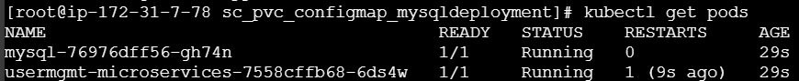
  - To avoid such situations, we can apply initContainers concept to our User management Microservice Deployment manifest.
  - We will see that in our next section but for now lets continue to test the application

